Week 4: 15-19 June 2026
This week, I aimed to do model optimization analysis. (run a YOLO model, and do layer-based error injection & profiling)

1 Run a YOLO Model on CPU/ GPU
After setting up the environment, I performed a test train and a ceil train for my PC:

Variables | Light Train (Initial Testing) | Medium Train (Ceil for my PC)
Epoch | 1 | 10
MIO-TCD train set usage [2] | 1% | 5%
Batches | 4 | 4
image size | 320 x 320 | 416 x 416
Trained on | CPU | CPU
Time used | < 30 mins | Around 15 hours
Table 1: Training Setups on my PC

Table 1 shows that I tested the system with a super light train, then moved on to a medium train. To limit training time, I lowered the variables, which may make the results less accurate than the model’s limit.

Here are the results for both trainings:
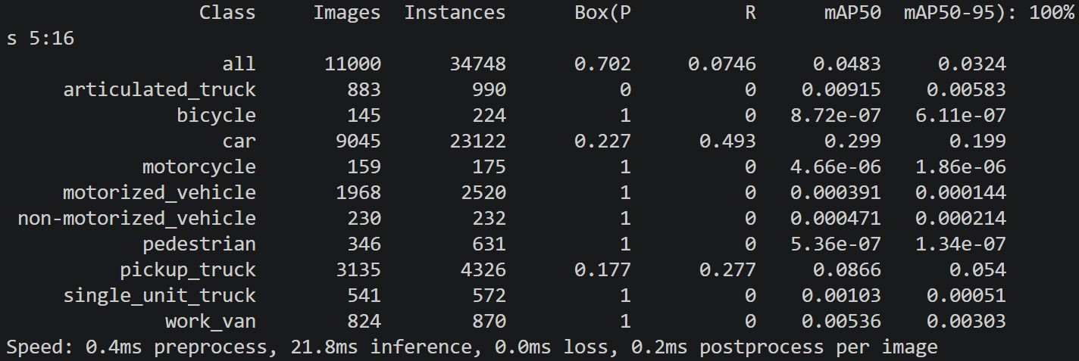
Figure 1: Light Train Results

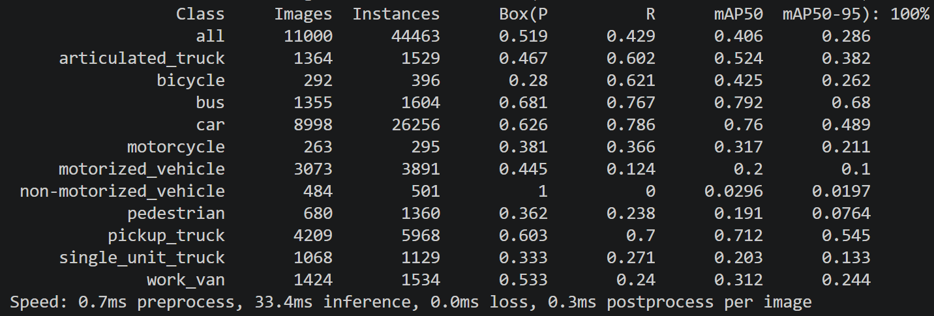
Figure 2: Medium Train Results

1.1 About Evaluation Metrics
For each class, Average Precision (AP) is calculated from the precision-recall curve, including Box(P) and R.

Box(P) means bounding-box precision. It measures how many predicted boxes are correct:
Precision = TP / (TP + FP)
A high precision means the model produces fewer false detections.

R, or Recall, measures how many real objects are successfully detected:
Recall = TP / (TP + FN)
A high recall means the model misses fewer objects.
Where TP, FP, and FN represent true positives, false positives, and false negatives.

A prediction is considered correct only if it predicts the correct class and its bounding box overlaps with the ground-truth box enough. This overlap is measured by Intersection over Union (IoU) [1]:
IoU = (overlap area) / (union area)
If the IoU is higher than a selected threshold, the prediction can be counted as a true positive. Otherwise, it is treated as a false positive or missed detection. For example:
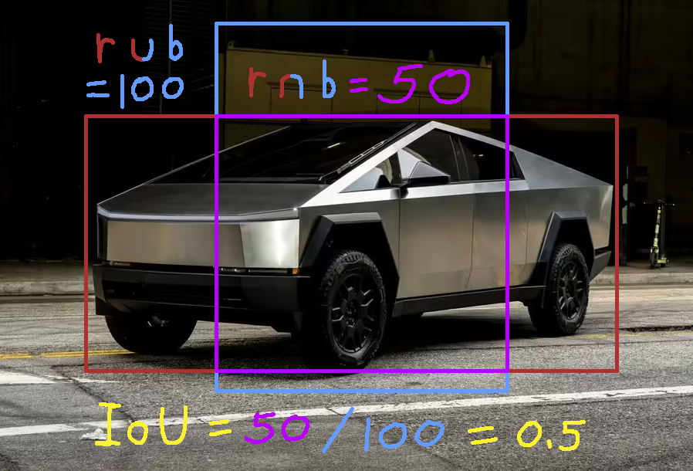
Figure 3: IoU example
For Figure 3, assume the red box is the ground truth box, and the blue box is the detected box. IoU can then be calculated by red intersect blue divided by red union blue. In this case IoU = 50/100 = 0.5.

mAP50 is the mean Average Precision when the IoU threshold is 0.50. A prediction is counted as correct if the predicted box and the ground-truth box have IoU >= 0.50.

mAP50-95 is stricter than mAP50 because higher IoU thresholds require more accurate bounding box locations. It averages mAP over IoU thresholds from 0.50 to 0.95 with a step size of 0.05:
mAP50-95 = average(mAP(50), mAP(55), ..., mAP(95))
This is the main metric used to evaluate object detection accuracy.

1.3 Training Result (local YOLO26n)

Stat | Metric Light | Metric Medium
Trained images | 99000 | 99000
Validation images | 11000 | 11000
Validation bounding boxes | 34748 | 44463
dataset usage | 1% | 5%
inference | 320 x 320 | 416 x 416
Predicted objects are correct (Precision) | 0.702 | 0.519
Real objects were found (Recall) | 0.0746 | 0.4296
Detection accuracy at IoU 0.5 (mAP50) | 0.0483 | 0.406
Stricter Detection accuracy (mAP50-95) | 0.0324 | 0.286
Table 2: Training Result Summarize

model | Parameters | FLOPs, resolution | mAP50-95
YOLOv5n [3] | 1.9M | 4.5G, 640 | 0.28
YOLO26n [4], [5] | 2.4M | 5.4G, 640 | 0.409
Table 3: Official YOLOv5n, YOLO26n Performances

In Table 2, although medium training improved accuracy over the initial light training, the mAP50-95 is only 0.286. Compared with Table 3, the result is slightly better than the official YOLOv5n, with mAP50-95 of 0.28. However, the official YOLO26n got 0.409 in mAP50-95. The main reason is that I only used only 3.33% of the official epoch, and 42.25% of the official image size to keep the training time low. [3], [4]

I am thinking of using Google Colab to perform the training [12], so I can use a GPU and larger variables without using up my PC's computational power. For the current state, I will use the medium train as the temporary model (since error injection and profiling do not require the best model).

2 Layer-based Profiling
For each layer, recorded the output shape and the average forward latency over repeated inference runs [6] using a fixed dummy input size of 416 x 416.

The bottleneck ranking was obtained by sorting layers according to their mean latency:

Latency Rank | Layer Id | Type | Parameters | Feature Map (feature, res) | Latency (ms) | Latency (%)
1 | 23 | Detect | 245 466 | - | 30.370 | 28.61
2 | 16 | C3k2 | 34 304 | 64, 52, 52 | 8.164 | 7.69
3 | 22 | C3k2 | 463 104 | 256, 13, 13 | 7.323 | 6.90
4 | 13 | C3k2 | 119 808 | 128, 26, 26 | 7.248 | 6.83
5 | 6 | C3k2 | 87 040 | 128, 26, 26 | 7.012 | 6.61
6 | 19 | C3k2 | 95 232 | 128, 26, 26 | 6.994 | 6.59
7 | 10 | C2PSA | 249 728 | 256, 13, 13 | 5.714 | 5.38
8 | 8 | C3k2 | 346 112 | 256, 13, 13 | 5.671 | 5.34
9 | 9 | SPPF | 164 608 | 256, 13, 13 | 5.189 | 4.89
10 | 2 | C3k2 | 6 640 | 64, 104, 104 | 5.111 | 4.81
11 | 4 | C3k2 | 26 080 | 128, 52, 52 | 4.257 | 4.01
12 | 5 | Conv | 147 712 | 128, 26, 26 | 2.311 | 2.18
13 | 3 | Conv | 36 992 | 64, 52, 52 | 2.259 | 2.13
14 | 1 | Conv | 4 672 | 32, 104, 104 | 1.653 | 1.56
15 | 7 | Conv | 295 424 | 256, 13, 13 | 1.616 | 1.52
16 | 0 | Conv | 464 | 16, 208, 208 | 1.578 | 1.49
17 | 20 | Conv | 147 712 | 128, 13, 13 | 1.091 | 1.03
18 | 17 | Conv | 36 992 | 64, 26, 26 | 1.080 | 1.02
19 | 14 | Upsample | 0 | 128, 52, 52 | 0.577 | 0.54
20 | 11 | Upsample | 0 | 256, 26, 26 | 0.427 | 0.40
21 | 15 | Concat | 0 | 256, 52, 52 | 0.210 | 0.20
22 | 12 | Concat | 0 | 384, 26, 26 | 0.109 | 0.10
23 | 18 | Concat | 0 | 192, 26, 26 | 0.104 | 0.10
24 | 21 | Concat | 0 | 384, 13, 13 | 0.092 | 0.09
- | (All) | - | 2.4M | - | 106.161 | 100
Table 4: Layer-based Profiling and Main Bottleneck for YOLO26n

Based on Table 4:
- Estimated FPS = (ms/sec) / (total latency) = 1000 / 106.161 = 9.42 FPS
- The layer-wise profiling result shows that the YOLO26n inference latency is concentrated in a small number of layers.
- The Detect layer was the single slowest layer, taking 30.37ms, which corresponds to 28.61% of the total measured latency.
- Top 5 layers already take 56.6% of total latency.
- Top 10 layers take 83.6% of total latency.

Layer Type | Count | Total Latency (ms) | Percent (%)
C3k2 | 8 | 51.78 | 48.78
Detect | 1 | 30.37 | 28.61
Conv | 7 | 11.59 | 10.92
C2PSA | 1 | 5.71 | 5.38
SPPF | 1 | 5.19 | 4.89
Upsample | 2 | 1.00 | 0.95
Concat | 4 | 0.52 | 0.49
(All) | 24 | 106.161 | 100
Table 5: Latency by Layer Type

Based on Table 5:
- Among the feature extraction and neck layers, C3k2 blocks were the main bottleneck.
- The eight C3k2 layers together consumed 51.78ms, or 48.78% of the total latency.
- This suggests that optimizing C3k2 blocks can provide the largest potential speed improvement.

The profiling result also shows that latency is not determined only by the number of parameters.
For example, layer 16 has only 34 304 parameters, but it is the slowest non-Detect layer because its output feature map has a relatively high spatial resolution of 52 x 52.

Therefore, both channel size and feature-map resolution should be considered when selecting layers for acceleration or compression [7].

3 Layer-based Error Injection
Layer-based error injection was performed by adding Gaussian activation noise to the output of one layer at a time during validation. For each injected layer, the model was evaluated again on the validation set, and the sensitivity score was calculated as [8]:
Sensitivity = clean mAP50-95 - injected mAP50-95
Where:
y_injected = y + sigma * std(y) * random_noise
y = layer output activation
sigma = error strength
random_noise = Gaussian noise, mean 0, std 1
Layers with larger mAP50-95 drops were considered more accuracy-sensitive, while layers with high latency and low sensitivity were considered better candidates for quantization, pruning, or hardware acceleration [11].

First, I created a 500-image validation subset (around 10 mins per error injection). This can prevent long running time (estimated 4 hours per injection).

Using mean drop mAP50-95 across the 4 runs with different seeds, the most sensitive layers are:

mAP Rank | Layer ID | Type | Latency | Mean Drop mAP50-95 | mAP Std
1 | 23 | Detect | 30.370 | 0.296417 | 0.000000
2 | 0 | Conv | 1.578 | 0.014994 | 0.001099
3 | 1 | Conv | 1.653 | 0.014513 | 0.001138
4 | 19 | C3k2 | 0.577 | 0.005320 | 0.002503
5 | 22 | C3k2 | 0.109 | 0.003334 | 0.001571
6 | 5 | Conv | 2.311 | 0.001978 | 0.002970
7 | 6 | C3k2 | 6.994 | 0.001658 | 0.001958
8 | 16 | C3k2 | 1.578 | 0.001635 | 0.001145
9 | 3 | Conv | 2.259 | 0.001589 | 0.002380
10 | 11 | Upsample | 4.257 | 0.000854 | 0.000405
11 | 13 | C3k2 | 2.259 | 0.000844 | 0.001480
12 | 17 | Conv | 1.091 | 0.000710 | 0.001037
13 | 14 | Upsample | 1.653 | 0.000486 | 0.000917
14 | 15 | Concat | 1.616 | 0.000226 | 0.000697
15 | 20 | Conv | 0.427 | 0.000204 | 0.000637
16 | 4 | C3k2 | 7.248 | 0.000193 | 0.001678
17 | 18 | Concat | 1.080 | 0.000031 | 0.002338
18 | 2 | C3k2 | 8.164 | -0.000028 | 0.000923
19 | 7 | Conv | 5.714 | -0.000082 | 0.001035
20 | 12 | Concat | 2.311 | -0.000307 | 0.001177
21 | 10 | C2PSA | 5.111 | -0.000405 | 0.001190
22 | 9 | SPPF | 5.189 | -0.000424 | 0.001243
23 | 21 | Concat | 0.210 | -0.000543 | 0.000324
24 | 8 | C3k2 | 5.671 | -0.001058 | 0.000771
Table 6: Averaged Sensitivity Result Across 4 Runs (sorted by mAP)

According to Table 6:
- Early Conv layers (0, 1) are the most error sensitive. (excepting detection)
- Among the slower layers, Layer 19 and Layer 6 (both C3k2) are the clearest sensitive bottlenecks.

Injecting Gaussian activation noise into the final Detect head caused the mAP50-95 to drop to 0.0 across all four seeds. This confirms that the final prediction head is extremely sensitive.

Four repeated layer-based error injection experiments were performed using Gaussian activation noise with sigma = 0.2 on a 500-image validation subset. The results were averaged to reduce randomness from noise injection.

The averaged ranking showed that the earliest convolution layers were relatively error-sensitive, while several later bottleneck layers such as C2PSA, SPPF, and some C3k2 blocks showed low sensitivity.

3.1 About the Negative Sensitivity Values
Negative sensitivity does not mean noise improves the model. It means:
- The measured change is very small
- It is within experimental variation
These layers can be treated as low sensitivity.

4 Combined Results
Here are the latency bottlenecks that merged with the 4-run sensitivity average which sorted by latency:

Layer ID | Type | Latency Rank | Latency (ms) | Sensitivity Rank | Mean Drop mAP50-95
23 | Detect | 1 | 30.370 | 1 | 0.296417
16 | C3k2 | 2 | 8.164 | 8 | 0.001635
22 | C3k2 | 3 | 7.323 | 5 | 0.003334
13 | C3k2 | 4 | 7.248 | 11 | 0.000844
6 | C3k2 | 5 | 7.012 | 7 | 0.001658
19 | C3k2 | 6 | 6.994 | 4 | 0.005320
10 | C2PSA | 7 | 5.714 | 21 | -0.000405
8 | C3k2 | 8 | 5.671 | 24 | -0.001058
9 | SPPF | 9 | 5.189 | 22 | -0.000424
2 | C3k2 | 10 | 5.111 | 18 | -0.000028
4 | C3k2 | 11 | 4.257 | 16 | 0.000193
5 | Conv | 12 | 2.311 | 6 | 0.001978
3 | Conv | 13 | 2.259 | 9 | 0.001589
1 | Conv | 14 | 1.653 | 3 | 0.014513
7 | Conv | 15 | 1.616 | 19 | -0.000082
0 | Conv | 16 | 1.578 | 2 | 0.014994
20 | Conv | 17 | 1.091 | 15 | 0.000204
17 | Conv | 18 | 1.080 | 12 | 0.000710
14 | Upsample | 19 | 0.577 | 13 | 0.000486
11 | Upsample | 20 | 0.427 | 10 | 0.000854
15 | Concat | 21 | 0.210 | 14 | 0.000226
12 | Concat | 22 | 0.109 | 20 | -0.000307
18 | Concat | 23 | 0.104 | 17 | 0.000031
21 | Concat | 24 | 0.092 | 23 | -0.000543
Table 7: Layer Latency and Sensitivity (sorted by Latency)

Remark:
- We are aiming to optimize high latency (red) and low mAP50-95 mean drop (green).
- Maybe the sensitivity is relatively low; some layers show slightly different results across seeds. To improve accuracy, I may run error injections with larger image sets or more seeds later.

To better select optimization candidates, a simple prunability score was defined:
Prunability(i) = Latency(i) / max(Mean Drop mAP50-95(i), 0.0004)
Where:
- max(..., 0.0004) prevents division by zero
- The score means: high latency + low sensitivity = better optimization candidate
- It avoids making every negative value automatically extremely huge

A higher prunability score means the layer has relatively high latency but low accuracy sensitivity. Therefore, it is a better candidate for pruning, quantization, or hardware acceleration.

4.1 Optimization Plan
sorted by planned modification order:

Layer ID | Type | Latency Rank | Latency (ms) | Sensitivity Rank | Mean Drop mAP50-95 | Prunability
10 | C2PSA | 7 | 5.714 | 21 | -0.000405 | 14285.00
8 | C3k2 | 8 | 5.671 | 24 | -0.001058 | 14177.50
9 | SPPF | 9 | 5.189 | 22 | -0.000424 | 12972.50
2 | C3k2 | 10 | 5.111 | 18 | -0.000028 | 12777.50
4 | C3k2 | 11 | 4.257 | 16 | 0.000193 | 10642.50
13 | C3k2 | 4 | 7.248 | 11 | 0.000844 | 8587.68
16 | C3k2 | 2 | 8.164 | 8 | 0.001635 | 4993.27
6 | C3k2 | 5 | 7.012 | 7 | 0.001658 | 4229.19
7 | Conv | 15 | 1.616 | 19 | -0.000082 | 4040.00
20 | Conv | 17 | 1.091 | 15 | 0.000204 | 2727.50
22 | C3k2 | 3 | 7.323 | 5 | 0.003334 | 2196.46
17 | Conv | 18 | 1.080 | 12 | 0.000710 | 1521.13
3 | Conv | 13 | 2.259 | 9 | 0.001589 | 1421.65
19 | C3k2 | 6 | 6.994 | 4 | 0.005320 | 1314.66
14 | Upsample | 19 | 0.577 | 13 | 0.000486 | 1187.24
5 | Conv | 12 | 2.311 | 6 | 0.001978 | 1168.35
15 | Concat | 21 | 0.210 | 14 | 0.000226 | 525.00
11 | Upsample | 20 | 0.427 | 10 | 0.000854 | 500.00
12 | Concat | 22 | 0.109 | 20 | -0.000307 | 272.50
18 | Concat | 23 | 0.104 | 17 | 0.000031 | 260.00
21 | Concat | 24 | 0.092 | 23 | -0.000543 | 230.00
1 | Conv | 14 | 1.653 | 3 | 0.014513 | 113.90
0 | Conv | 16 | 1.578 | 2 | 0.014994 | 105.24
23 | Detect | 1 | 30.370 | 1 | 0.296417 | 102.46
Table 8: Layer Latency and Sensitivity

Prunability was calculated as:
Latency(i) / max(Mean Drop mAP50-95(i), 0.0004)
The lower bound 0.0004 prevents very small or negative sensitivity values from causing unstable division. A higher prunability value indicates a layer with relatively high latency and low measured accuracy sensitivity, making it a stronger candidate for pruning, quantization, or hardware acceleration.

These results provide guidance for the next optimization stage, including quantization, pruning, and potential hardware acceleration.
(C3k2 > C2PSA > SPPF: Layer 10 > 8 > 9 > 2 > 4 > 13 > 16 > 6 > …)

5 Scripts (code snippets)
5.1 Dataset conversion
The MIO-TCD labels were converted from pixel-based xyxy bounding boxes to YOLO normalized xywh labels.
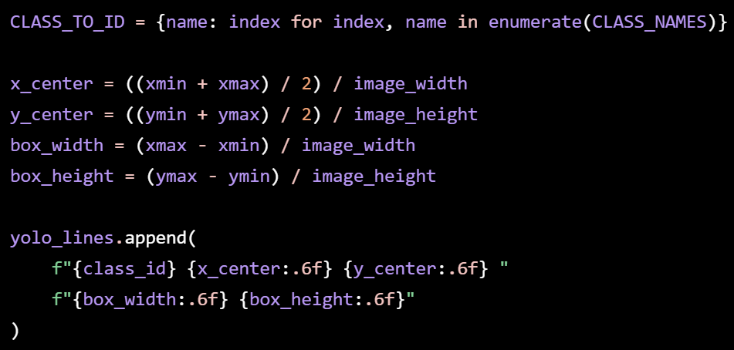
A 10% validation split was created with class-balanced selection, and the final YOLO dataset structure was saved as:
- images/train
- images/val
- labels/train
- labels/val
- mio_tcd.yaml

5.2 Baseline training
YOLO26n was trained on the converted MIO-TCD dataset using CPU. A reduced setup was used to keep training time manageable.
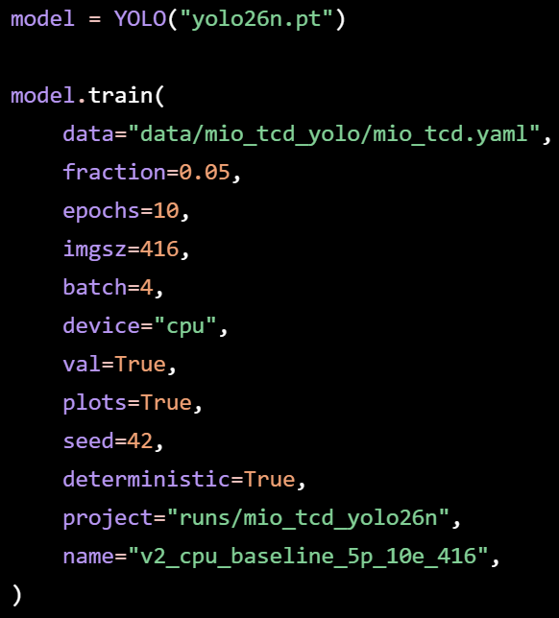
This trained model was used as the baseline checkpoint for profiling and error injection.

5.3 Validation subset
A 500-image validation subset was created to reduce CPU runtime during repeated error injection experiments.
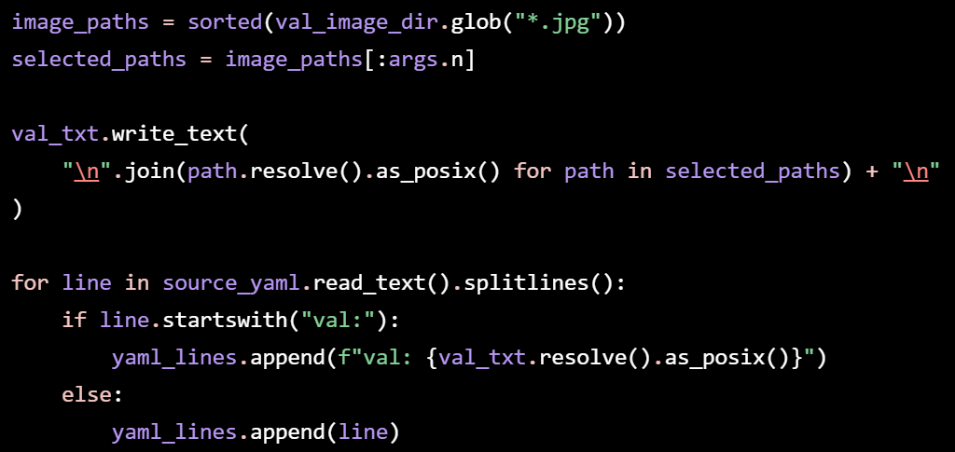
This allowed Ultralytics validation to run on the subset instead of the full validation set.

5.4 Layer-wise latency profiling
Layer-wise profiling was done using PyTorch forward hooks on YOLO26n top-level layers.
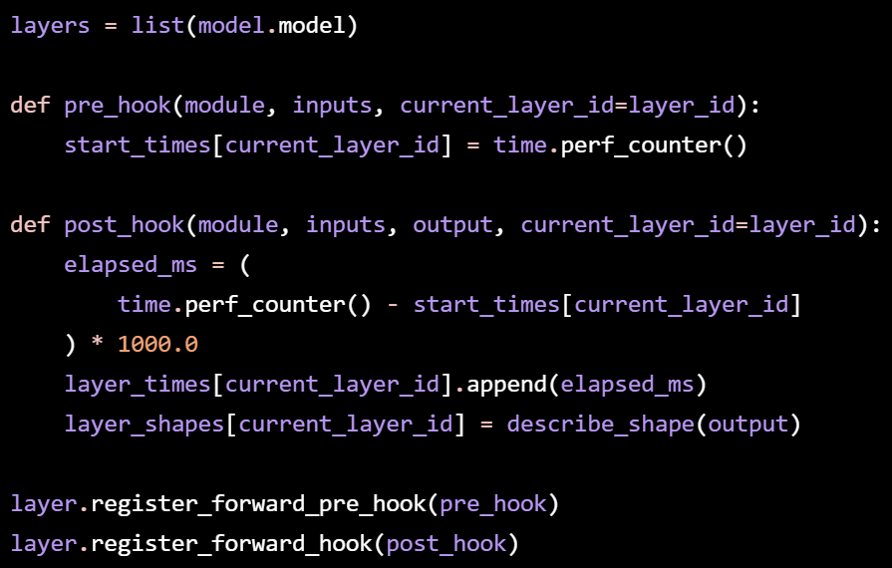
A dummy input was used with warm-up runs before measurement.
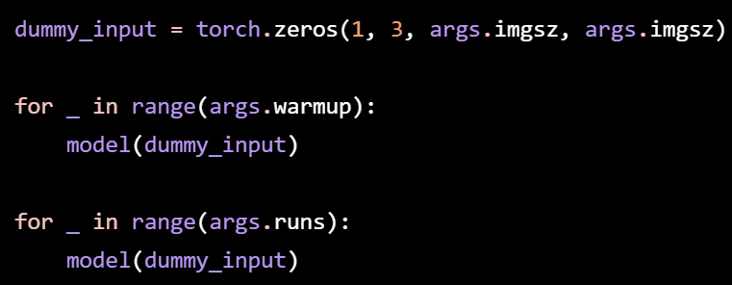
The script saved each layer’s output shape, mean latency, latency percentage, and bottleneck ranking.

5.5 Layer-based error injection
Error injection was performed by adding Gaussian noise to one layer output at a time.
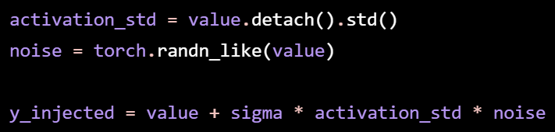
This represents:
y_injected = y + sigma × std(y) × N(0, 1)
The model was validated after injecting each layer, and sensitivity was measured by mAP50-95 drop.
The experiment was repeated with four random seeds:
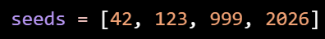
The final sensitivity score was reported as the mean and standard deviation of mAP50-95 drop across the four runs.

5.6 Output tables
The scripts produced three main tables:
- layer_latency_table.csv
- bottleneck_ranking.csv
- error_sensitivity_average.csv
These were combined to compare: Layer latency vs. accuracy sensitivity
This helped identify which layers are good candidates for quantization, pruning, or hardware acceleration.

Results are in the previous sections.

6 Summarize
Overall, I trained a YOLO26n on my CPU. The performance is not as good as the official one. I will try to improve it by modifying the training setup.

I also performed layer-based profiling and error injection. The result of error injection may vary for different seeds. I may later increase the sample subset size or test on more seeds to reconfirm the result.

The current plan is to optimize C3k2 > C2PSA > SPPF, with the layer order 10 > 8 > 9 > 2 > 4 > 13 > 16 > 6 > ….

Next, I will consider quantization and pruning, along with any methods that may reduce size and increase speed.

References

[1] Ultralytics, Performance Metrics Deep Dive, 2023. https://docs.ultralytics.com/guides/yolo-performance-metrics/

[2] Luo et al., MIO-TCD: A New Benchmark Dataset for Vehicle Classification and Localization, 2018. https://doi.org/10.1109/TIP.2018.2848705

[3] Jocher et al., ultralytics/yolov5: v6.1 - TensorRT, TensorFlow Edge TPU and OpenVINO Export and Inference, 2022. https://zenodo.org/records/6222936

[4] Ultralytics, Ultralytics YOLO26, 2026. https://docs.ultralytics.com/models/yolo26/

[5] Jocher et al., Ultralytics YOLO26: Unified Real-Time End-to-End Vision Models, 2026. https://arxiv.org/abs/2606.03748

[6] PyTorch, PyTorch Profiler, 2025. https://docs.pytorch.org/tutorials/recipes/recipes/profiler_recipe.html

[7] Zhang et al., Dive into Deep Learning, 2023. https://d2l.ai/

[8] Camuto et al., Explicit Regularisation in Gaussian Noise Injections, 2020. https://arxiv.org/abs/2007.07368

[9] Han et al., Deep Compression: Compressing Deep Neural Networks with Pruning, Trained Quantization and Huffman Coding, 2015. https://arxiv.org/abs/1510.00149

[10] Liang et al., Pruning and Quantization for Deep Neural Network Acceleration: A Survey, 2021. https://arxiv.org/abs/2101.09671

[11] Dong et al., HAWQ-V2: Hessian Aware trace-Weighted Quantization of Neural Networks, 2020. https://arxiv.org/abs/1911.03852

[12] Google, Google Colab FAQ, n.d. https://research.google.com/colaboratory/faq.html

